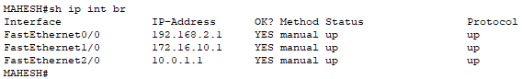
Fig: Router Intefaces

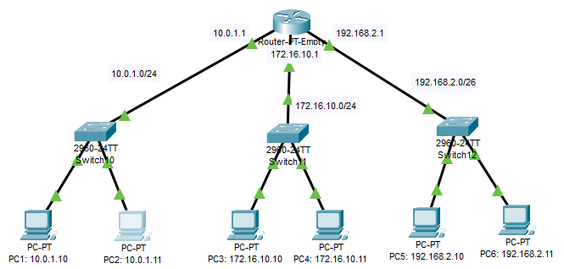
Fig: Topology of the Network

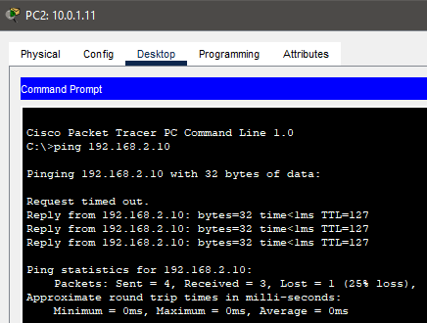
Fig: Testing connection from pc2 to pc5

